CHAPTER 10 FINANCIAL MARKETS
Financial Intermediation: is the process by which allocation of funds is done.
The main sectors of economic system
(a) Households which save funds
(b) Business firms which invest these funds
Consequences of the allocative function performed by the financial market:
(1) Rate of return to households - higher
(2) Scarce resources allocated to - firm with highest produce
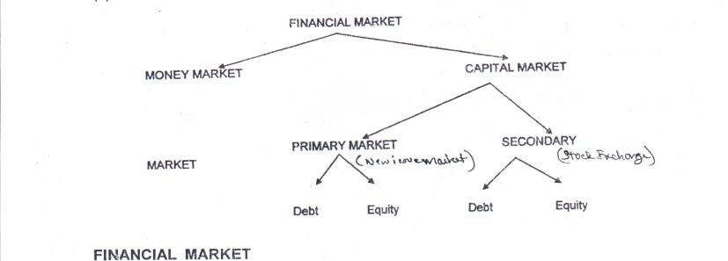

FINANCIAL MARKET
Concept – It is a market for the creation & exchange of financial assets. Financial Markets exist wherever a financial transaction occurs.
FUNCTIONS OF FINANCIAL MARKET (FMPR)
- Facilitates price discovery - interaction between households (suppliers of funds) and firms (demand) establish price for financial assets.
- Mobilizes and channeling savings- transfer surplus funds from saver to investor in most productive manner.
- Provides liquidity to financial assets - facilitate purchase and sale of financial assets, i.e. making them easily converted into cash.
- Reduces the cost of transaction - saves time, money, and effort of buyers and sellers by providing a common platform for fulfillment of individual needs.
MONEY MARKET
It is a market for short term funds - deals in monetary assets - period of maturity is upto one year.
Nature:
- Short term funds - maximum tenure of one year; some even issued for a single day.
- High safety - short duration and involvement of reputed companies.
- High Liquidity - existence Discount Finance House of India (DHFI).
- Large Amount - money market instruments are quite expensive.
- Major Participants - RBI, Commercial Banks.
Purpose: to raise short term funds for meeting shortages of cash and utilizing excess funds for earning returns.
- Instruments of Money Market:
(1) Treasury bills
(2) Commercial Paper
(3) Call money
(4) Certificate of Deposit
(5) Commercial bill
l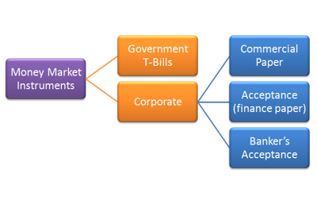
- CAPITAL MARKET
An ideal capital market:
(1) Finance is available at a reasonable cost.
(2) Efficient in respect of information that it delivers.
(3) Allocates capital productively.
(4) Minimizes transaction cost.

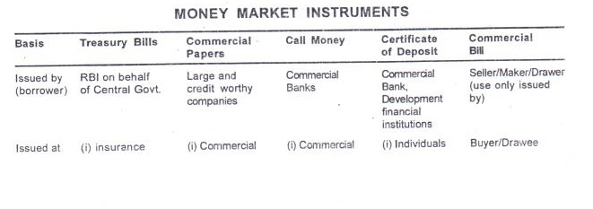
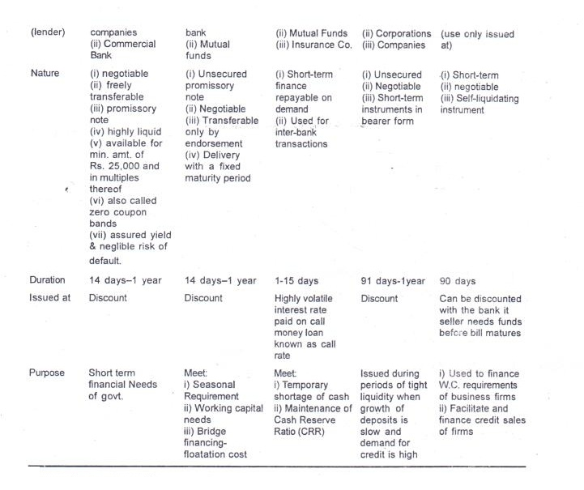

Some terms used :
CRR
Commercial banks have to maintain a min. cash balance known as Cash Reserve Ratio. The RBI changes the CRR from time to time which in turn affects the amount of funds available to be given as loans by commercial banks.
Discount
The difference between the price at which instruments are issued and their redemption value is the interest receivable on them and is called discount.
Call Rates
There is an inverse relationship between call rates and other short-term money market instruments.
Bridge Financing
Cost of floatation met by commercial papers.
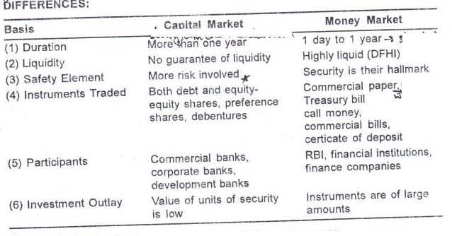

SEBI- SECURITIES AND EXCHANGE BOARD OF INDIA Purpose:
Create an environment to facilitate efficient mobilization and allocation_of resources through the securities market.
Encourages innovation and stimulates competition.

Objectives : (PPRR)
(1) Regulation of stock exchange - to promote their orderly
functioning.
(2) Protection of rights and interest of individuals - guide and
educate them
(3) Prevention of trading malpractices - achieve balance between securities industry and its statutory regulations.
(4) Regulating and developing a code of conduct - help make intermediaries more competitive and professional.

The needs of the interest groups satisfied by SEBl:
- To the issuer - a market place which helps in raising funds in an easy and efficient manner.
- To the investors. Provide protection of their rights and interests
- To the intermediaries . offer a competitive, professionalized and expanding market.

Functions of SEBI :
1. Regulatory Function
(1) Registration of brokers and sub brokers
(2) Registration of mutual funds
(3) Regulation of brokers, underwriters, etc.
(4) Regulation of takeover bids
(5) Levy fee or other charges
(6) Performing and exercising such power under Securities Contracts (Regulation) Act 1956.
2. Development functions
(1) Training of Intermediaries
(2) Develop capital markets by adapting a flexible approach
(3) Conducting research and publishing information
3. Protective Function
(1) Prohibition of fraudulent and unfair trade practices
(2) Controlling insider trading
(3) Interest protection
(4) Promotion of fair practices

STOCK EXCHANGE
A Stock exchange is an insti
Definition:
According to the Securities Contract (Regulation) Act 1956, a stock exchange means any body of individuals whether incorporated or not, constituted for the purpose of assisting, regulating or controlling the business of buying and selling or dealing in securities.
Functions of Stock Market/Stock Exchange: ( PPPCSS)
(1) Providing Liquidity and Marketability to existing securities - give investors the chance to disinvest and reinvest.
(2) Pricing of securities - mechanism (forces of demand & supply) of constant valuation through which prices are determined.
(3) Providing scope for Speculation - sufficient scope within the provisions of law for speculative activity in a restricted and controlled manner.
(4) Contribution to economic growth - through disinvestment and reinvestment savings get channelized in the most productive avenue.
(5) Spreading of equity cult - ensures wider share ownership.
(6) Safety of transaction - membership well-regulated and dealing well-defined.
PRIMARY MARKET

Definition : It is a market, which deals with new securities being issued for the first time.
Function : Facilitates the transfer of investible funds from savers to, entrepreneurs seeking to establish new enterprises or to expand existing ones through the issue of securities for the first time.
Methods of Floatation

- Offer through prospectus
Most popular method of raising funds. A prospectus makes a direct appeal to public to investors to raise capital through advertisements.

- Offer for sale
Offer through intermediaries(stock brokers)

- Private Placement
The selected clients (institutional investors)----COMPANY DECIDES THAT EG. UTI, LIC----DOESNOT COME THROUGH STOCK EXCHANGE

- Right Issue
To existing shareholders.

- E-IPOs
Issue of capital is through online screen based trading system. This is called Initial Public Offer(IPO)
It requires appointment of brokers who are registered by SEBI and appointment of a Registrar having electronic connectivity with the stock exchange.

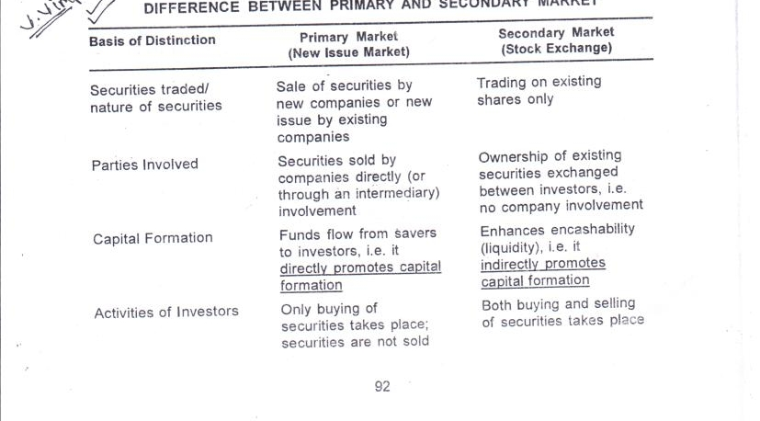

Price Determination |  | Prices are determined and decided by the management of the company |  | Prices are determined by demand and supply for the securities
Location |  | There is no fixed Geographical location |  | Location at specified places

SOME IMPORTANT TERMS:
Dematerialization – A process of holding securities in an electronic form. It enables shares to be transferred to some other account just like cash & ensures settlement of all trades through a single account in shares.
- Demat securities can even be pledged to get loans
- There is no danger of loss, theft, forgery of share certificates. 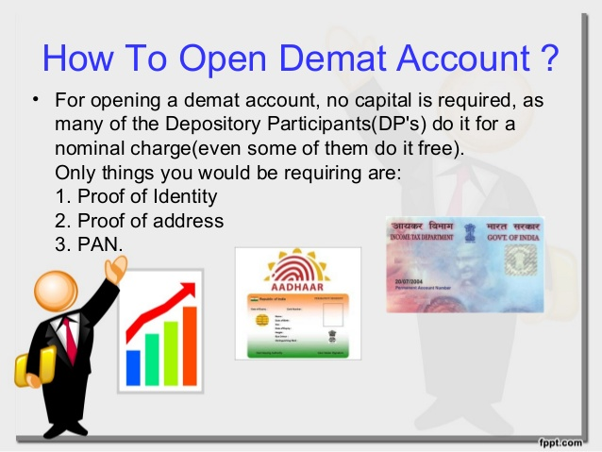
Depository: A depository is like a bank and keeps securities in electronic form on behalf of the investor. It is a technology driven electronic storage system.
There are 2 depositories in India:-
- National Securities Depositories Limited (NSDL) – First/largest depository in India, Promoted as a Joint Venture of IDBI, UTI & NSE.
- Central Despository Securities Limited (CDSL)- to commence operations & was promoted by Bank of India &BombayStockExchange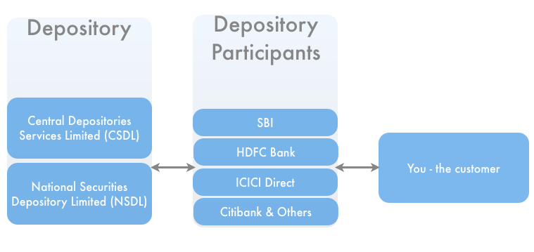
Depository Participant- serves as an intermediary between investor & Depository (NSDL/CDSL) & is authorized to maintain accounts of dematerialized shares,
Bank
Stock Brokers permitted to become DP
NBFC’s
Clearing Corporations
(GOVT.AGENCY) 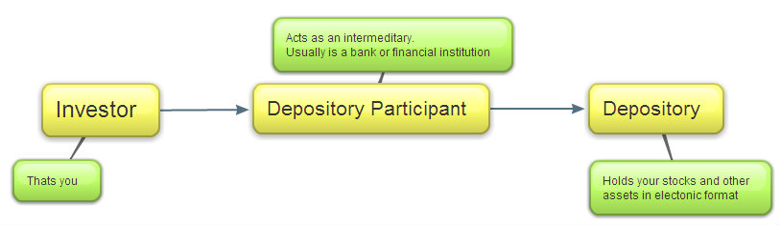
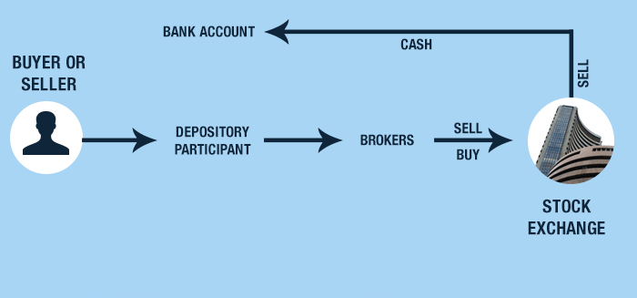
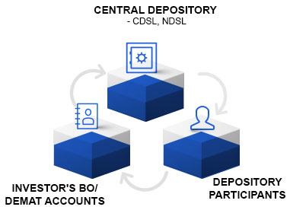

TRADING PROCEDURE ON A STOCK EXCHANGE

- If an investor wishes to buy or sell any security he has to first approach a registered broker or sub-broker and enter into an agreement with him. The investor has to sign at broker-client agreement and client registration form

- The investor has to open a 'demat' account or 'beneficial owner' (BO) account with a depository participant (DP) for holding and transferring securities in the demat form. He will also have to open a bank account for cash transactions in the securities market.
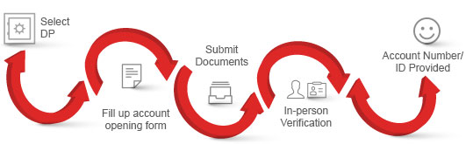
- The investor then places an order with the broker to buy or sell shares. Clear instructions have to be given about the number of shares and the price at which the shares should be bought or sold. As order confirmation slip to the investor by the broker.
- The broker then will go on-line and connect to the main stock exchange and match the share and best price available.
- When the shares can be bought or sold at the price mentioned, it will be communicated to the broker's terminal and the order will be executed electronically. The broker will issue a trade confirmation slip to the investor.
- After the trade has been executed within 24 hours the broker issue a Contract Note. This is an important document as it is legally enforceable and helps to settle disputes/claim between the investor and the broker.
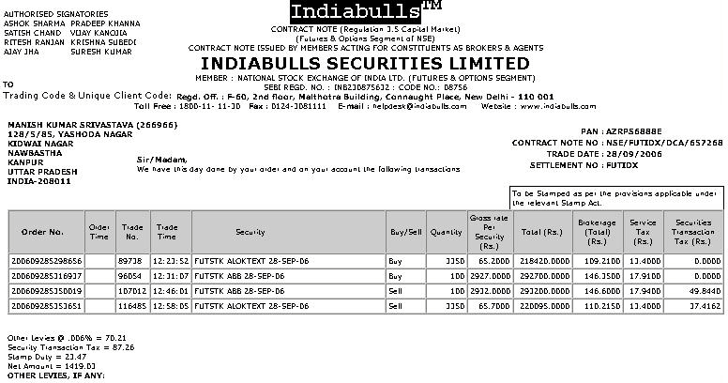
- The investor has to delivered shares sold or pay cash for the shares bought. This should be done immediately after receiving the contract note or before the day when the broker shall make payment or delivery of shares to the exchange.

- Cash is paid or securities are delivered on pay-in day, which is before the T +2 day.
- On the T +2 day the exchange will deliver the share or make payment to the other broker. This is called the pay-out day.
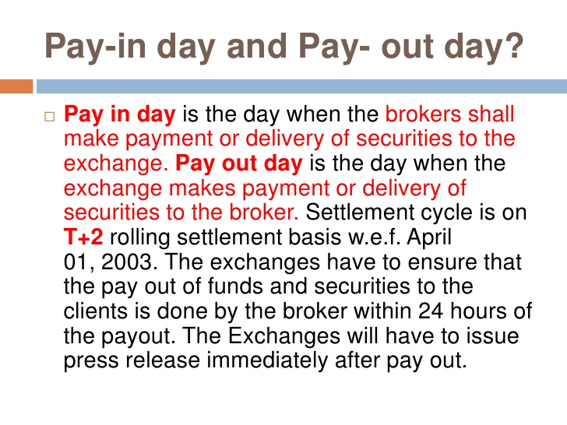

- The broker can make delivery of shares in demat form directly to the investor’s demat account—ON WEDNESDAY EVENING I WILL GET SHARES IN MY DP ACCOUNT
